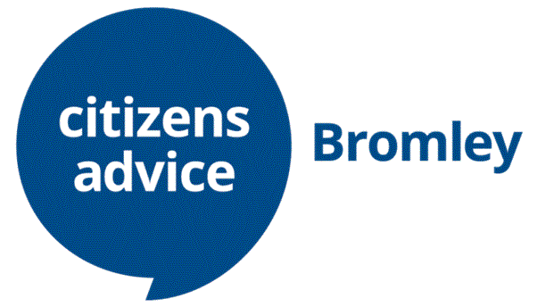

**Job Description**

**Adviser**

Our Advisers see clients either face to face at our locations in Bromley town centre, Anerley or Orpington, or speak to them over the phone.

They explore the client’s circumstances to gain as full a picture of the client as possible, and identify key issues where the client needs advice.

Using a range of sources, find the advice that’s most appropriate for the client and present it to the client in a way that the client can understand and act on it.

Give the client a range of options on what they can do, explaining the pros and cons of each option, and identify next steps for the client to do

Where necessary, advisers signpost or refer clients to a range of external organisations for specialist help and advice.

Once the appointment is over, advisers write up the client’s case using our bespoke database.

**What will you do?**

* Make a real difference to people’s lives
* Talk to clients over the phone or face to face
* Explore why the client has come for help
* Use a range of sources to give the client information and advice, and help them to understand their options
* Support clients to take action to resolve their problems; this might include drafting or writing letters, making phone calls, or referring the client to another organisation
* Use the CA database to record clients’ problems and what action you’ve taken
* Identify trends and emerging issues and gather evidence that can be used in national and local campaigns to alleviate clients’ problems.
* Complete a comprehensive Citizens Advice (CA) Adviser Learning programme that will give you the skills you need to interview and advise our clients

**What’s in it for you?**

* Volunteer in a supportive environment
* Make a positive impact in your community
* Grow and develop valuable skills such as communication, listening and problem solving
  + If you’ve been out of the workplace and are looking to return to work, these skills can potentially increase your employability
* Learn about a range of issues such as benefits, debt, employment, and housing
* Work with a range of different people
* If you're training to be a solicitor, you may be able to get up to six months off your training contract. See Solicitors Regulation Authority for more information.

**What do you need?**

* You don’t need specific qualifications, but you’ll need to be non-judgmental and respect views, values and cultures that are different to your own
* Be a good listener
* Have excellent verbal and written communication skills
* Be able to understand information and explain it to others
* Be willing to learn about and follow the Citizens Advice aims, principles and policies, including confidentiality and data protection
* Be willing to undertake training in your role
* Have good maths and IT skills

**How much time do you need to give?**

* We ask for 2 full days a week for minimum of 12 months, inclusive of training programme. Initial training is for 12 weeks and training to be a full adviser can take up to 9 months

At present we are mainly working remotely but are starting to move back to our offices in Bromley, Penge and Orpington.

Advisers living within or close to the London Borough of Bromley can either work in an office or remotely. Reasonable travel expenses reimbursed.

Volunteers who live further away, however, would be expected to continue to work from home.